WebDev Bootcamp: Assignment 1

1/ Relative vs Absolute positioning in CSS:

CSS position: absolute

The value absolute for the CSS property position enables an element to ignore sibling elements and instead be positioned relative to its closest parent element that is positioned with relative or absolute . The absolute value removes an element entirely from the document flow. By using the positioning attributes top , left, bottom and right , an element can be positioned anywhere as expected.

Example:

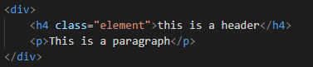 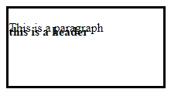

|  |
| --- |
| .element {  position: absolute;  } |

2/ CSS Box sizing and more precisely margin vs padding:

The property box-sizing of CSS box model:

The CSS box model is a box that wraps around an HTML element and controls the design and layout. The property box-sizing controls which aspect of the box is determined by the height and width properties. The default value of this property is content-box , which renders the actual size of the

element including the content box; but not the paddings and borders. The value

border-box , on the other hand, renders the actual size of an element

including the content box, paddings, and borders.

Margin vs padding:

Padding is the space between the content area and the border. It can be set in pixels or percent while margin is the amount of spacing outside of an element’s border.

|  |
| --- |
| .container {  box-sizing: border-box;  } |

Padding:

|  |
| --- |
| .content-header {  padding: 20px 10px;  } |

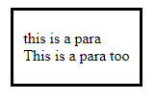

In the example above, the 5px refers to the vertical padding (top and bottom) while 10px refers to the horizontal padding. We are giving the element with class “content-header” a 5px padding from top and bottom, and a 10px padding from the left and the right side.

Whilst in this example:

|  |
| --- |
| .content-header {  padding: 5px 6px 8px 10px;  } |

We are giving the element with class ‘content-header’ a top padding of 5px, a right padding of 6px, a bottom padding of 8px, and a left padding of 10px. It works clockwise.

Same thing applies to margins.